### **Assignment 3:** Research and compare SDLC models suitable for engineering projects. Present findings on Waterfall, Agile, Spiral, and V-Model approaches, emphasizing their advantages, disadvantages, and applicability in different engineering contexts.

### **1. Waterfall Model**

#### **Description**

The Waterfall model is a linear sequential flow where each phase must be completed before the next phase begins. The phases typically include requirements, design, implementation, verification, and maintenance.

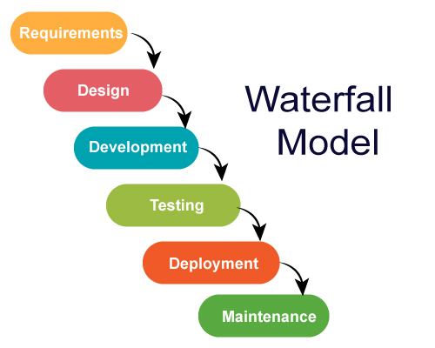

#### **Advantages**

* **Simple and Easy to Understand**: Its linear structure makes it easy to understand and use.
* **Well-Structured Documentation**: Due to its sequential nature, extensive documentation is often produced, which can be beneficial for future maintenance and knowledge transfer.
* **Easy to Manage**: Each phase has specific deliverables and a review process.

#### **Disadvantages**

* **Inflexibility**: It is difficult to go back to any phase once it is completed. Changes can be costly and time-consuming.
* **Late Testing**: Testing phase comes late in the development process, which can lead to the discovery of critical issues at a late stage.
* **Not Suitable for Complex Projects**: The model is less effective for complex and object-oriented projects.

#### **Applicability**

* **Simple Projects**: Best suited for simple, small-scale projects with clear and fixed requirements.
* **Regulated Industries**: Suitable for projects where thorough documentation and approvals are required (e.g., defense, aviation).

### **2. Agile Model**

#### **Description**

Agile is an iterative and incremental approach to software development. It emphasizes flexibility, customer collaboration, and frequent delivery of small, functional product increments.

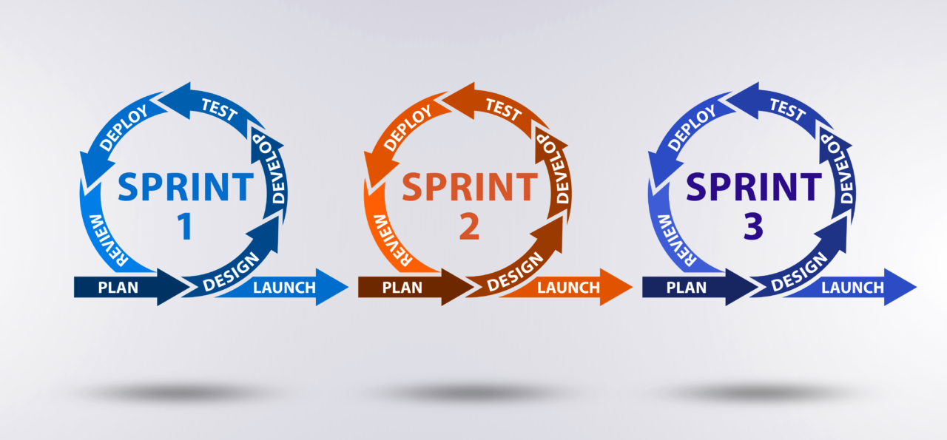

#### **Advantages**

* **Flexibility**: Can adapt to changing requirements even late in the project.
* **Customer Collaboration**: Continuous feedback from the customer ensures that the product meets their needs.
* **Early and Frequent Delivery**: Regular releases ensure that the product is tested and delivered incrementally, reducing risks.

#### **Disadvantages**

* **Lack of Documentation**: Emphasis on working software over comprehensive documentation can lead to insufficient documentation.
* **Requires Experienced Team**: Agile teams need to be highly skilled and collaborative.
* **Scope Creep**: Continuous changes and additions can lead to scope creep if not managed properly.

#### **Applicability**

* **Dynamic Projects**: Ideal for projects where requirements are expected to change frequently.
* **Customer-Centric Products**: Suitable for projects where continuous customer feedback is crucial (e.g., web and mobile applications).

### **3. Spiral Model**

#### **Description**

The Spiral model combines iterative development with systematic aspects of the Waterfall model. It emphasizes risk analysis and incorporates elements of both prototyping and sequential models.

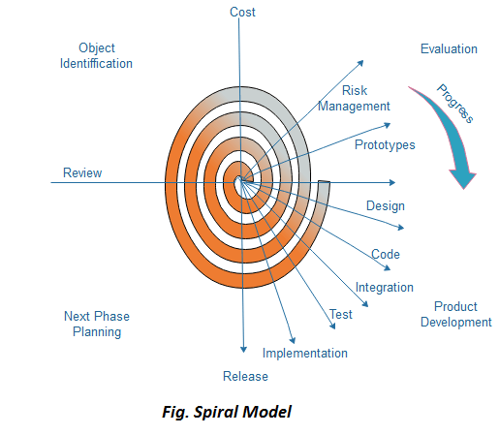

#### **Advantages**

* **Risk Management**: Continuous risk assessment and mitigation at each iteration.
* **Flexibility and Adaptation**: Combines the best features of both incremental and Waterfall models.
* **Early Prototyping**: Early development of prototypes to validate requirements and designs.

#### **Disadvantages**

* **Complex and Costly**: Managing and performing risk analysis can be complex and expensive.
* **Requires Expertise**: Needs highly skilled and experienced team members for effective risk analysis and management.
* **Documentation Heavy**: Can involve extensive documentation and planning.

#### **Applicability**

* **High-Risk Projects**: Suitable for large, complex projects with significant risk (e.g., aerospace, automotive).
* **Custom Products**: Ideal for projects requiring frequent iterations and refinements based on feedback.

### **4. V-Model (Validation and Verification Model)**

#### **Description**

The V-Model is an extension of the Waterfall model, where each development stage is associated with a testing phase. It emphasizes verification and validation processes.

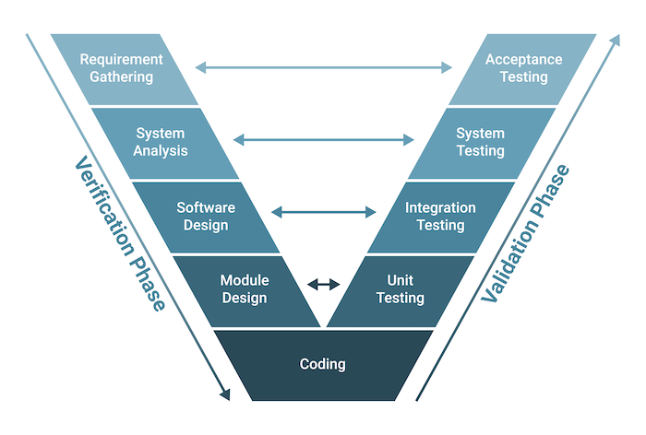

#### **Advantages**

* **Validation and Verification**: Strong focus on testing ensures quality and reliability.
* **Structured and Disciplined**: Clear, well-defined stages make project management straightforward.
* **Defect Prevention**: Early detection of defects through corresponding validation activities.

#### **Disadvantages**

* **Inflexibility**: Like the Waterfall model, it is difficult to accommodate changes once the process is underway.
* **Time-Consuming**: Extensive testing and documentation can prolong the development process.
* **Not Suitable for Small Projects**: Overhead may be too high for small-scale projects.

#### **Applicability**

* **Critical Systems**: Ideal for projects where failure is not an option and extensive validation is required (e.g., medical devices, financial systems).
* **Well-Defined Requirements**: Best for projects with clearly defined requirements and low probability of changes.

### **Comparison Summary**

* **Waterfall** is simple and structured but inflexible and not ideal for complex projects.
* **Agile** is flexible and customer-focused but can suffer from scope creep and lacks documentation.
* **Spiral** offers strong risk management and flexibility but is complex and costly.
* **V-Model** emphasizes validation and verification but shares Waterfall's inflexibility and is time-consuming.

### **Applicability in Engineering Contexts**

* **Waterfall**: Suitable for projects with stable, well-understood requirements such as construction or infrastructure projects.
* **Agile**: Best for software development, R&D projects, and any engineering project requiring frequent iteration and customer feedback.
* **Spiral**: Suitable for high-risk, large-scale engineering projects like aerospace and automotive engineering.
* **V-Model**: Ideal for critical systems with stringent validation needs, such as healthcare devices and financial systems.

Each model has its strengths and weaknesses, and the choice depends on the specific requirements, risk profile, and flexibility needed for the engineering project at hand.